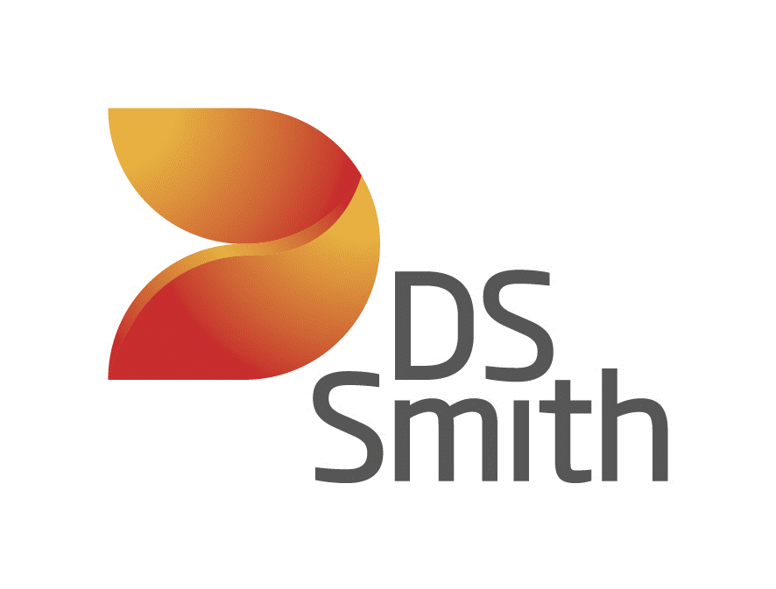
High Level Design For
RCA Knowledge Management - Phase - I

DOCUMENT CONTROL
Version | Author | Date | Notes
0.1 | Miguel-Angel Gonzalez | 02/03/2026 | Initial version
Version | Author | Function | Date | Action
 | N/A
DISTRIBUTION LIST

Approvals
Role | Approver | Date | Permission Granted
Sponsor/Product Owner | Adrian Pinder
Head Of Engineering | Gerald Schmidt
TDA chairperson | Olga Maria Lopez
Solution Architect | Neha Tripathi
Data governance lead | Kane Balkwill
Table of Contents
1. INTRODUCTION 1
➢ Overview 2
➢ Purpose of the Document 2
➢ In Scope 2
➢ Out of Scope 3
2. BUSINESS REQURIMENTS 3
➢ Summary 4
➢ Objectives 4
➢ Functional Requirements 4
➢ Non-Functional Requirements 6
3. SOLUTION DESIGN AND ARCHITECTURE 6
➢ Introduction 6
➢ Inference 7
➢ Data Ingestion Pipeline 9
➢ SSO 12
➢ AWS Services 12
➢ Azure Services 12
➢ Document Chunking Module 13
4. SCALING THE APPLICATION 15
5. STREAMLIT FRONTEND DESIGN 15
6. DATA GOVERNANCE & COMPLIANCES 16
7. ROLES AND RESPONSIBILITIES 16
➢ Roles and responsibilities 16
➢ Technical Design Authorities 16

- INTRODUCTION
  - Overview
The solution implements a Retrieval-Augmented Generation (RAG) subsystem on AWS to ground LLM-generated insights for papermaking cost analysis. The retrieval layer is implemented using an Amazon OpenSearch collection configured for vector search, storing document chunks, embeddings, and structured metadata (mill, area, grade, tags, language, and source references). Queries are embedded using Amazon Bedrock Titan Embeddings and retrieved using OpenSearch k-NN (optionally combined with lexical search for tag identifiers and engineering terminology). The generation layer uses Amazon Bedrock (Claude) to produce explainable narratives that interpret ML-predicted cost components and SHAP contributions, while citing the retrieved source chunks for traceability.
  - Purpose of the Document
This document provides the High-Level Design (HLD) for the Retrieval-Augmented Generation (RAG) system supporting the AI-Powered Cost Analysis platform for papermaking operations.
The purpose of this document is to:
- Describe the overall architecture of the RAG system hosted in AWS.
- Define the major system components and their interactions.
- Document the integration between:
  - Machine Learning cost prediction models,
  - SHAP (Shapley) contribution outputs,
  - The domain knowledge retrieval layer,
  - Large Language Model (LLM) generation services.
- Establish architectural decisions and technology selections, including:
  - Amazon OpenSearch (vector database),
  - Amazon Bedrock (embeddings and LLM inference),
  - AWS storage and compute services.
- Provide sufficient technical detail for architecture review, governance approval, and implementation planning.
  - In Scope
The scope of this document includes the high-level design of the RAG system supporting the AI-Powered Cost Analysis platform, specifically:
    - Architecture of the AWS-hosted RAG solution.
    - Implementation of the vector database using Amazon OpenSearch.
    - Embedding generation and LLM inference using Amazon Bedrock.
    - Knowledge ingestion, chunking, embedding, and indexing processes.
    - Retrieval and prompt orchestration for grounded insight generation.
    - Integration with ML model outputs, including predicted cost components and SHAP contributions.
  - Out of Scope
The following are outside the scope of this document:
    - Development and training of ML cost prediction models.
    - Detailed infrastructure configuration (Low-Level Design).
    - Real-time process control or automation systems.
    - User interface implementation details.

- BUSINESS REQURIMENTS
  - Summary
The RAG system shall support the AI-Powered Cost Analysis platform by providing reliable, explainable, and domain-grounded interpretation of machine learning cost predictions and SHAP (Shapley) contributions.
The solution must enable:
    - Context-aware explanation of predicted cost components (e.g., fibre, steam, starch, electricity).
    - Interpretation of SHAP contributions in operational papermaking terms.
    - Retrieval of mill-specific and domain knowledge to ground AI responses.
    - Reduction of manual analysis time for engineers and process experts.
    - Increased trust in AI-generated insights through traceability and source grounding.
    - The system must operate within the enterprise AWS environment and align with corporate security, governance, and AI explainability standards.

  - Functional Requirements
The RAG system shall provide the following functional capabilities:
    - FR1 – Knowledge Ingestion and Indexing
      - Ingest papermaking domain documentation and mill-specific documents.
      - Perform text extraction, chunking, and embedding generation.
      - Store document chunks, embeddings, and metadata in Amazon OpenSearch.
    - FR2 – Vector-Based Retrieval
      - Generate embeddings for user queries and contextual ML outputs.
      - Retrieve relevant document chunks using semantic vector search.
      - Support metadata filtering (e.g., mill, area, language, document type).
      - Support keyword-based retrieval for tag identifiers and technical terms.
    - FR3 – Integration with ML Outputs
      - Accept structured inputs from ML cost prediction models.
      - Incorporate SHAP (Shapley) contributions into prompt construction.
      - Contextualize cost drivers using retrieved domain knowledge.
    - FR4 – Grounded Insight Generation
      - Generate explanations using Amazon Bedrock LLM services.
      - Ensure responses are grounded in retrieved documentation.
      - Provide traceability to source documents where applicable.
      - FR5 – Security and Access Control
      - Enforce role-based access to the RAG system.
      - Restrict access to mill-specific documentation where required.
    - FR6 – Monitoring and Logging
      - Log retrieval and generation requests for auditability.
      - Support monitoring of system performance and usage.
    - FR7 – User Interface: Chatbot in Shiny Dashboard
      - Provide a Shiny-based dashboard UI that exposes the RAG system through a chatbot interface.
      - Allow users to ask questions about predicted cost components and SHAP drivers.
      - Allow users to provide operational context (e.g., grade, time window, machine area) to guide retrieval and responses.
    - FR8 – Automated Weekly Reporting (RMarkdown)
      - Generate an automated weekly report using RMarkdown.
      - Produce the report in English and German.
      - Include AI-generated insights grounded in the RAG knowledge base, based on weekly model outputs (predictions + SHAP contributions).
      - Store and make reports accessible to stakeholders (e.g., via dashboard download or shared storage).
  - Non-Functional Requirements
- NFR1 – Performance
- The system shall return chatbot responses within an acceptable interactive latency (target: a few seconds under normal load).
- Weekly report generation shall complete within the defined batch processing window.
- NFR2 – Availability
- The system shall be deployed in AWS with high availability appropriate for analytical workloads.
- The RAG service shall not impact the availability of core production systems.
- NFR3 – Scalability
- The architecture shall support scaling to multiple mills and increased document volumes.
- The OpenSearch vector index shall support growth in stored documents and embeddings without major architectural changes.
- NFR4 – Security
- All data shall be encrypted in transit and at rest.
- Access shall be controlled using IAM-based role and policy management.
- Mill-specific documentation shall be logically isolated where required.
- NFR5 – Explainability and Traceability
- AI-generated insights shall be grounded in retrieved documentation.
- The system shall enable traceability to source documents where applicable.
- Logs of retrieval and generation requests shall be retained for audit and review purposes.
- NFR6 – Maintainability
- The system shall allow re-indexing and knowledge base updates without full system redesign.
- Configuration of embeddings, retrieval parameters, and prompts shall be modular and configurable.
- NFR7 – Compliance and Governance
- The solution shall align with enterprise AI governance and cloud security standards.
- The system shall not expose confidential data to external services outside the approved AWS environment.

- SOLUTION DESIGN AND ARCHITECTURE
  - Introduction
This chapter describes the high-level architecture of the Retrieval-Augmented Generation (RAG) system supporting the AI-Powered Cost Analysis platform.
The solution is designed as a modular, AWS-hosted architecture that integrates:
  - Machine learning cost prediction outputs (including SHAP contributions),
  - A vector-based knowledge retrieval layer,
  - Large Language Model (LLM) generation services,
  - A Shiny-based user interface and automated reporting engine.
The architecture ensures scalable, secure, and explainable AI-driven insight generation grounded in papermaking domain knowledge and mill-specific documentation.
  - High-Level Architecture
The solution consists of the following logical layers:
1. Data & Knowledge Layer
Papermaking domain library
Mill-specific documentation
Structured metadata (tags, units, machine areas, language)
ML model outputs (predictions and SHAP contributions)
2. Ingestion & Indexing Layer
Document extraction and chunking
Embedding generation
Storage of chunks, embeddings, and metadata in Amazon OpenSearch
3. Retrieval Layer
Query embedding generation
Vector similarity search in OpenSearch
Optional metadata filtering and keyword search
Retrieval of top-k relevant knowledge chunks
4. Generation Layer
Prompt orchestration combining:
User query,
ML predictions,
SHAP contributions,
Retrieved context
LLM inference via Amazon Bedrock
Grounded explanation generation
5. Application Layer
Shiny dashboard with chatbot interface
Automated weekly reporting using RMarkdown (English and German)
Integration with cost analysis workflows
The architecture separates knowledge storage, retrieval, and generation to ensure scalability, maintainability, and explainability.
  - AWS Services to Be Used
The solution leverages the following AWS services:
Amazon OpenSearch
Vector database for storing embeddings and document chunks
Supports k-NN vector search and metadata filtering
Amazon Bedrock
Titan Embeddings model for vector generation
Claude (or equivalent LLM) for grounded text generation
Amazon S3
Storage of source documents
Storage of generated weekly reports
Optional storage for ingestion artifacts
AWS Compute (e.g., ECS / EKS / EC2)
Hosting of the RAG application service
Hosting of the Shiny dashboard
AWS IAM
Role-based access control
Secure service-to-service authentication
AWS CloudWatch
Monitoring, logging, and observability
  - Architecture Diagram Description
The high-level architecture consists of the following components and flows:
A. User & Application Layer
    - Shiny Dashboard (Chatbot UI)
      - Primary interactive interface.
      - Handles user questions, context selection (grade, timeframe, cost component), and display of AI-generated insights.
      - Contains the embedded RAG logic.
    - Automated Weekly Reporting (RMarkdown)
      - Scheduled batch process.
      - Uses the same embedded RAG logic to generate narrative explanations in English and German.
B. Application Backend (Within Shiny Environment)
The Shiny application performs:
  - Integration with ML model outputs (predictions + SHAP contributions)
  - Query construction
  - Embedding requests to Amazon Bedrock
  - Retrieval queries to Amazon OpenSearch
  - Prompt construction
  - LLM invocation via Amazon Bedrock
  - Response formatting and citation handling
There is no standalone orchestration microservice; the RAG workflow is implemented within the application layer.
C. Knowledge & Retrieval Layer
    - Amazon OpenSearch (Vector Index)
      - Stores document chunks, embeddings, and metadata.
      - Supports:
        - k-NN vector search
        - Keyword search for tag identifiers
        - Metadata filtering (mill, area, language, document type)
    - Amazon S3
      - Stores source documents for ingestion.
      - Stores generated weekly reports.
D. Foundation Model Services
    - Amazon Bedrock – Titan Embeddings
      - Generates embeddings for:
        - Knowledge chunks (offline ingestion)
        - User queries (online)
    - Amazon Bedrock – LLM (e.g., Claude)
      - Generates grounded explanations and summaries.
E. Security & Operations
    - AWS IAM – Access control between Shiny application, OpenSearch, and Bedrock.
    - Amazon CloudWatch – Logging and monitoring.
  - Data Flow Description
Offline Flow – Knowledge Ingestion
    - Domain and mill-specific documents are stored in Amazon S3.
    - A controlled ingestion process:
      - Extracts text,
      - Splits into chunks,
      - Generates embeddings via Bedrock,
      - Indexes chunks + metadata into OpenSearch.
    - The OpenSearch index becomes the retrieval knowledge base.
Online Flow – Chatbot Interaction
    - User submits question via Shiny chatbot.
    - Shiny backend retrieves relevant:
      - ML predictions,
      - SHAP contributions,
      - User-selected filters.
    - Shiny generates an embedding of the query using Bedrock Titan Embeddings.
    - Shiny queries OpenSearch:
      - Vector similarity search,
      - Optional keyword + metadata filtering.
    - Retrieved chunks are inserted into a structured prompt.
    - Shiny calls Bedrock LLM to generate the response.
    - The grounded answer (with references) is displayed in the chatbot.
Batch Flow – Weekly Reporting
  - A scheduled job triggers RMarkdown rendering.
  - Weekly ML outputs (predictions + SHAP summaries) are loaded.
  - For each section of the report:
    - The embedded RAG logic retrieves relevant knowledge.
    - The LLM generates grounded explanations.
  - The report is rendered in English and German.
  - Final output is stored in Amazon S3 and made accessible via the dashboard or controlled distribution.
- SCALING THE APPLICATION

The solution shall be designed to support increasing user load, document volume, and multi-mill expansion without architectural redesign.
  - Application Layer Scaling
The Shiny application shall support horizontal scaling (multiple instances behind a load balancer).
Interactive chatbot workloads and weekly reporting jobs shall be logically separated to prevent resource contention.
The application shall remain stateless to enable elastic scaling.
  - Retrieval Layer Scaling
Amazon OpenSearch shall be configured to support growth in document volume and concurrent vector queries.
Metadata filtering shall be used to limit search scope and improve performance.
  - Foundation Model Scaling
The application shall handle Bedrock rate limits through retry and throttling mechanisms.
Caching mechanisms may be implemented to reduce repeated embedding and generation calls.
  - Multi-Mill Expansion
The architecture shall support logical separation of mill-specific data.
The solution shall scale to additional mills by extending indexing and metadata configuration without structural redesign.

- SHINY FRONTEND DESIGN

  - Overview
The Shiny frontend provides the user interface for interacting with the AI-Powered Cost Analysis platform. It integrates analytical visualization, guided drill-down diagnostics, and a chatbot interface powered by the RAG system.
The design focuses on usability, clarity of cost drivers, and explainable AI interaction.
  - Multi-Language Support
The frontend shall support English and German.
Language selection shall apply consistently to:
    - Static UI elements,
    - Cost component labels,
    - Explanatory texts,
    - AI-generated chatbot responses,
    - Automated weekly reports.
Language context shall be passed to the RAG prompts to ensure correct output language.
  - Guided Drill-Down Analysis
The dashboard shall provide structured analytical navigation across:
    - Grades
    - Cost components (e.g., fibre, steam, starch, electricity)
    - Cost drivers (based on SHAP contributions)
The drill-down flow shall:
    - Allow users to move from high-level cost overview to detailed driver-level analysis.
    - Highlight dominant SHAP contributors.
    - Provide contextual explanations via integrated AI insights.
    - Maintain consistency between numerical analytics and AI-generated narratives.
  - Chatbot Interface
The dashboard shall include an embedded chatbot that:
    - Allows users to ask free-text questions about cost behaviour and drivers.
    - Incorporates selected context (grade, period, cost component).
    - Provides grounded explanations based on retrieved knowledge.
    - Supports follow-up questions within the same session.
The chatbot complements, but does not replace, structured drill-down analysis.

- DATA GOVERNANCE & COMPLIANCES
The application operates on session-based memory. All user data, including user query, is automatically cleared once the user performs a hard refresh or logs out. No user activities are logged or stored — only minimal application-level events are captured through terminal logs for monitoring purposes, without any data persistence.

- ROLES AND RESPONSIBILITIES
  - Roles and responsibilities
For effective and an efficient deployment of the solution, it is important that there is a clear understanding of the roles and responsibilities across the solution design document.
Task  Role | Solution Architect | ITBP | Enterprise Arch | TDA Group | CTO
Write the solution document | R | C / I | I | I | I
Appraise the solution document | I | R | R | I | R
Approval Solution Document | I | I | I | R | I
  - Technical Design Authorities
Role | Name | Solution Design Sign-off
Solution Architect | Kumar Mayank
Product Owner | Adrian Pinder
Data Factory Engineering Lead | Gerald Schmidt

